

INSTRUCTIONS AND WARRANTY

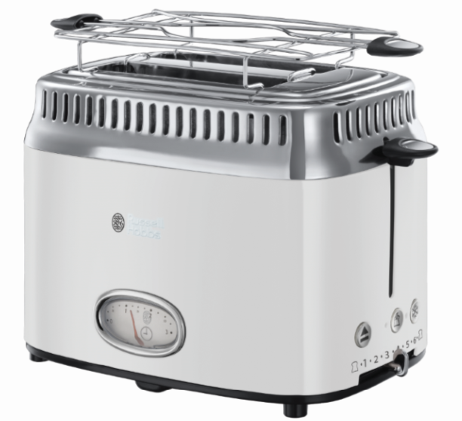

MODEL NO.
21680-56SA (Russell Hobbs Retro Toaster Red)
21681-56SA (Russell Hobbs Retro Toaster Black)
21682-56SA (Russell Hobbs Retro Toaster Cream)
21684-56SA (Russell Hobbs Retro Toaster White)

Congratulations on purchasing our Russell Hobbs Retro Toaster. Each unit is manufactured to ensure safety and reliability. Before using this appliance for the first time, please read the instruction manual carefully and keep it for future reference.
FEATURES OF THE RUSSELL HOBBS RETRO TOASTER
- Stainless steel 2 slice toaster with high gloss finish
- Stunning retro design
- Countdown gauge showing the toasting time remaining
- Fast Toasting technology*
- Up to 65% faster toasting*
- Lift and look feature
- Check your toast without cancelling
- Removable crumb tray
- Cancel, Frozen & Reheat functions
- Variable browning control
- Bun warmer
- For domestic use only
- 2 year warranty (1 year retail • 1 year extended upon online registration of product • visit www.russellhobbs.co.za)

*When tested against Russell Hobbs toaster 20720-56

PARTS DIAGRAM
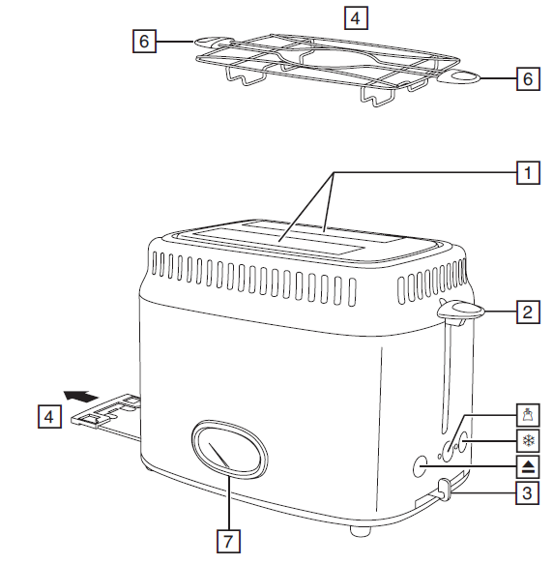

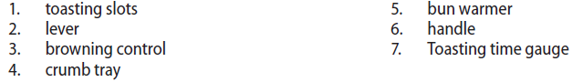

IMPORTANT SAFEGUARDS
When using any electrical appliance, basic safety precautions should always be followed including the following:
- Please read the instructions carefully before using any appliance.
- Always ensure that the voltage on the rating label corresponds to the mains voltage in your home.
- Incorrect operation and improper use can damage the appliance and cause injury to the user.
- The appliance is intended for household use only. Commercial use invalids the warranty and the supplier can not be held responsible for injury or damage caused when using the appliance for any other purpose than that intended.
- Avoid any contact with moving parts.
- This appliance is not intended for use by persons (including children) with reduced physical, sensory or mental capabilities, or lack of experience and knowledge, unless they have been given supervision or instruction concerning use of the appliance by a person responsible for their safety.
- Children should be supervised to ensure that they do not play with the appliance.
- Close supervision is required when any appliance is used near or by children or invalids.
- Check the power cord and plug regularly for any damage. If the cord or the plug is damaged, it must be replaced by the manufacturer or a qualified person in order to avoid an electrical hazard.
- Do not use the appliance if it has been dropped or damaged in any way. In case of damage, take the unit in for examination and/or repair by an authorised service agent
- To reduce the risk of electric shock, do not immerse or expose the motor assembly, plug or the power cord to water or any other liquid.
- Never immerse the unit in water or any other liquid for cleaning purposes.
- Remove the plug from the socket by gripping the plug. Do not pull on the cord to disconnect the appliance from the mains. Always unplug the unit when not in use, before cleaning or when adding or removing parts.
- The use of accessory attachments that are not recommended or supplied by the manufacturer may result in injuries, fire or electric shock.
- A short cord is provided to reduce the hazards resulting from becoming entangled in or tripping over a longer cord.
- Do not let the cord hang over the edge of a table or counter. Ensure that the cord is not in a position where it can be pulled on inadvertently.
- Do not allow the cord to touch hot surfaces and do not place on or near a hot gas or electric burner or in a heated oven.
- Do not use the appliance on a gas or electric cooking top or over or near an open flame.
- Use of an extension cord with this appliance is not recommended. However, if it is necessary to use an extension lead, ensure that the lead is suited to the power consumption of the appliance to avoid overheating of the extension cord, appliance or plug point. Do not place the extension cord in a position where it can be pulled on by children or animals or tripped over.
- This appliance is not suitable for outdoor use. Do not use this appliance for anything other than its intended use.
- DO NOT carry the appliance by the power cord.
- Do not leave this appliance unattended during use. Always unplug the unit when not in use or before cleaning.
- Always operate the appliance on a smooth, even, stable surface. Do not place the unit on a hot surface.
- The manufacturer does not accept responsibility for any damage or injury caused by improper or incorrect use, or for repairs carried out by unauthorised personnel.
- In case of technical problems, switch off the toaster and do not attempt to repair it yourself. Return the appliance to an authorised service facility for examination, adjustment or repair. Always insist on the use of original spare parts.
Failure to comply with the above mentioned pre-cautions and instructions, could affect the safe operation of this machine.
- When using a single toasting slot, don’t let anything get into the other slot, as both slots will be heated when the lever is lowered.
- Don’t let the toasting slots become covered during toasting.
- If bread gets jammed, unplug the toaster, let it cool down fully then carefully remove the bread that’s jamming it. Don’t use anything sharp, such as a knife or fork, you may damage the elements.
27. Don’t toast “buttered” items or try to make toasted sandwiches in the toaster as
this will create a fire hazard.
28. Don’t use torn, curled up, or broken slices of bread, as these may jam the eject mechanism.
29. Unplug the toaster when not in use, before moving and before cleaning. Let it cool down fully before cleaning and storing away.
30. Clean the crumbs out of your toaster frequently. A build-up of crumbs is unhygienic and could cause a fire hazard.
31. Don’t use the toaster unless the crumb tray is in place and closed.
32. Don’t use the toaster for any purpose other than those described in these
instructions.

OPERATING INSTRUCTIONS

BEFORE USING THE TOASTER FOR THE FIRST TIME
- Turn the browning control to the highest setting (6).
- Operate the toaster without any bread inside, to cure the new elements to remove the protective coating. This may smell a bit, but it’s nothing to worry about. Ensure the room is well ventilated.

TOASTING BREAD
- Place the toaster upright, on a stable, level, heat resistant surface, clear of curtains and other combustible materials. Don’t put it on or near anything that could be damaged even by moderate sources of heat.
- Plug the cable into the power socket.
- Place bread into the toasting slots (maximum thickness of bread 25mm).
- Turn the browning control to the required setting (1 = light, 6 = dark)
- Press the loading lever down fully – it won’t lock down unless the toaster is connected to the electricity supply.
- When it’s done, the toast will pop up and the elements will turn off automatically.

EJECT
To stop the toaster before it’s finished, press the cancel button. The toast will pop up and the elements will turn off.

FROZEN BREAD
- This feature takes the guesswork out of toasting frozen bread.
- Leave the browning control at your preferred setting, put the frozen bread into the slots, lower the bread carriage handle and then press the defrost button.
- The toasting time gauge will show the toasting time and start to count down.
- When it reaches 0, the toast will pop up.

REHEATING TOAST
- You must only reheat plain, unbuttered toast and you should reheat toast at the lowest setting.
- Press the reheat 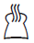button. The reheat light will come on.
- Press the loading lever handle down fully – it won’t lock down unless the toaster is connected to the electricity supply.
- The toasting time gauge will move to the 30 second mark and start to count down.
- When it reaches 0, the toast will pop up.

Note: Only reheat plain, “unbuttered” toast.

TOASTING TIME GAUGE
- The gauge shows the time it will take to make the toast at the selected browning control setting.
- If you cancel toasting by pressing the  pause button, the gauge will stay at the time it was showing when you pressed the button. If you restart toasting by lowering the lever, the gauge will move to the 3 mark then readjust to show the correct toasting time.
- If you change the position of the browning control during toasting, the gauge will move to the 3 mark then readjust to show the correct toasting time.
- It will also adjust itself automatically when you use the frozen bread or reheat button

BUN WARMER
Note: Don’t use the bun warmer to warm frozen, buttered, coated, iced, or filled buns.

- Sit the bun warmer on top of the toaster, with the feet inside the slots.
- Sit the buns on top of the bun warmer.
- Set the browning level to 1, then lower the lever.
- When the lever pops up, remove the warmed buns.
- Don’t touch the bun warmer wires – they’ll be hot.
- Remove the bun warmer before using the toaster normally.

HINTS & TIPS
- When toasting more than one slice of bread, use slices of similar size, thickness and freshness.
- Old (yesterday’s) bread contains less moisture, so makes crisper toast.
- Old or thin bread cooks faster than fresh or thick bread, so use a lower setting.
- Sweet bread products (tea cakes, fruit loaf, etc.) brown much more quickly than
ordinary bread, so should be toasted on a lighter setting.

Crumbs
- Clean the crumbs out of your toaster frequently, to avoid a build-up of crumbs. This is unhygienic and could cause a fire hazard.
- Unplug the toaster and let it cool down, then remove and empty the crumb tray.
- Wipe it with a damp cloth, dry and then replace it in the toaster.
- Don’t use the toaster unless the crumb tray is fitted and closed.

Jamming
If the bread jams in the toaster, unplug the toaster and leave it to cool down before trying to release the jam.

CLEANING AND MAINTENANCE
- This toaster is for household use only and is not user-serviceable.
- Do not open or change any parts by yourself. Please refer to a qualified electrical service department or return to the supplier if servicing is necessary.
- Always remember to unplug the toaster from the electrical outlet when not in use and before cleaning. Let it cool before cleaning and storing away.
- The body of the toaster and the crumb tray should be cleaned with a damp cloth. Do not let water enter the toaster.
- Don’t let anything enter the slots, you might damage the elements.
- Do not use bleach or other abrasive substance or solvents to clean your toaster as it can be damaging to the finish.
- To remove stubborn spots/marks, wipe the surfaces with a cloth slightly dampened in soapy water or mild non-abrasive cleaner. Rinse and dry with a clean, dry, soft cloth

ENVIRONMENTAL PROTECTION

To avoid environmental and health problems due to hazardous substances in electrical and electronic goods, appliances marked with this symbol mustn’t be disposed of with unsorted municipal waste, but recovered, reused, or recycled.
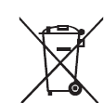

STORING THE APPLIANCE
- Unplug the unit from the wall outlet and clean all the parts as instructed above. Ensure that all parts are dry before storing.
- Store the appliance in its box or in a clean, dry place.
- Never store the appliance while it is still dirty.
- Never wrap the power cord around the appliance.

SERVICING THE APPLIANCE
There are no user serviceable parts in this appliance. If the unit is not operating correctly, please check the following:
- You have followed the instructions correctly
- That the unit has been wired correctly and that the wall socket is switched on.
- That the mains power supply is ON.
- That the plug is firmly in the mains socket.

If the appliance still does not work after checking the above:
- Consult the retailer for possible repair or replacement. If the retailer fails to resolve the problem and you need to return the appliance, make sure that:
- The unit is packed carefully back into its original packaging.
- Proof of purchase is attached.
- A reason is provided for why it is being returned.

If the supply cord is damaged, it must be replaced by the manufacturer or an authorised service agent, in order to avoid any hazard. If service becomes necessary within the warranty period, the appliance should be returned to an approved Home of Living Brands (Pty) Ltd service centre. Servicing outside the warranty period is still available, but will, however, be chargeable.

CHANGING THE PLUG

Should the need arise to change the fitted plug, follow the instructions below.
This unit is designed to operate on 220V-240V current only. Connecting to other power sources may damage the appliance. Connect a three-pin plug as follows:
The wires in this mains lead are coloured in accordance with the following code:
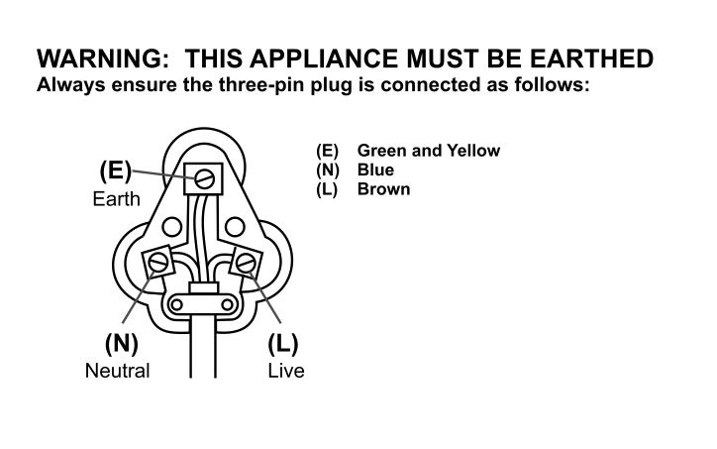

PLEASE AFFIX YOUR PROOF OF PURCHASE/RECEIPT HERE
IN THE EVENT OF A CLAIM UNDER WARRANTY THIS RECEIPT MUST BE PRODUCED.

W A R R A N T Y AND EXTENDED WARRANTY

- Home of Living Brands (Pty) Limited ("Home of Living Brands") warrants to the original purchaser of this product ("the customer") that this product will be free of defects in quality and workmanship which under normal personal, family or household use and purpose may manifest within a period of 1 (one) year from the date of purchase ("warranty period").
- Home of Living Brands shall extend the warranty period for a further period of 1(one) year (“extended warranty period*”), on condition that the purchaser registers the product on the website, within 12 months from the date of purchase of the product. The website address for registration is as follows: http://russellhobbs.co.za/info-pages/warranty-info.aspx. The extended warranty period only applies to products purchased on or after 1 October 2017.
- Where the customer has purchased a product and it breaks, is defective or does not work properly for the intended purpose, the customer must notify the supplier from whom the customer bought the product ("the supplier") thereof within the warranty period or if applicable, the extended warranty period. Any claim in terms of this warranty must be supported by a proof of purchase. If proof of purchase is not available, then repair, and/or service charges may be payable by the customer to the supplier.
- The faulty product must be taken to the supplier's service centre to exercise the warranty.
- The supplier will refund, repair or exchange the product in terms of this warranty subject to legislative requirements. This warranty shall be valid only where the customer has not broken the product themselves, or used the product for something that it is not supposed to be used for. The warranty does not include and will not be construed to cover products damaged as a result of disaster, misuse, tamper, abuse or any unauthorised modification or repair of the product.
- This warranty will extend only to the product provided at the date of the purchase and not to any expendables attached or installed by the customer.
- If the customer requests that the supplier repairs the product and the product breaks or fails to work properly within 3 (three) months of the repair and not as a result of misuse, tampering or modification by or on behalf of the customer, then the supplier may replace the product or pay a refund to the customer, subject to the supplier’s discretion.
- The customer may be responsible for certain costs where products returned are not in the original packaging, or if the packaging is damaged. This will be deducted from any refund paid to the customer.
HOME OF LIVING BRANDS (PTY) LTD (JOHANNESBURG)
JOHANNESBURG TEL NO. (011) 490-9600
CAPE TOWN TEL NO. (021) 552-5161
DURBAN TEL NO. (031) 303-1163
www.homeoflivingbrands.com
www.russellhobbs.co.za
www.facebook.com/RussellHobbsSA

EXCLUSIONS TO W A R R A N T Y AND EXTENDED WARRANTY

1. Any accessories supplied with the product, including but not limited to, bowls, jugs, mills or carafes made either of glass or plastic and supplied with this appliance (hereinafter referred to as “the accessory or accessories”), is warranted to be free from material and workmanship defects for the duration of the appliance warranty.

2. The accessories should give trouble free service when used in accordance with the directions described in the instruction manual. However, the accessories will be damaged if subjected to impact, and this damage is not covered by the warranty. Such impact damage can occur either from the outside (if for example it is dropped or knocked against a hard surface), or from within (if for example foreign objects are placed within the accessories and the power is switched on).

3. Should you need to replace an accessory during the warranty period; a claim for a free replacement will only be considered if the item (including all shards and broken parts) is returned to the nearest HOLB service centre for examination.

4. The remains of the accessory will be carefully examined by the relevant professionals and if it is determined (at the sole discretion of HOLB) that the damage was caused by impact, then the claim will be refused and will not be covered by the warranty or any extended warranty.

5. Any replacement part provided in terms of clause 4 above will become a chargeable item payable by the customer.

